027_Abhishek_Ojha

DESIGN ANALYSIS AND ALGORITHM

PRACTICAL NO 1

**Experiment No -1 Date of Experiment : 27 August 2021**

**Program : -** Write a program to implement Insertion sort and find the running time of the algorithm

# Example :-

**Input :-** A[4, 6, 8, 1, 3, 32, 12]

**Algorithm :**

**-**

**Fig :**

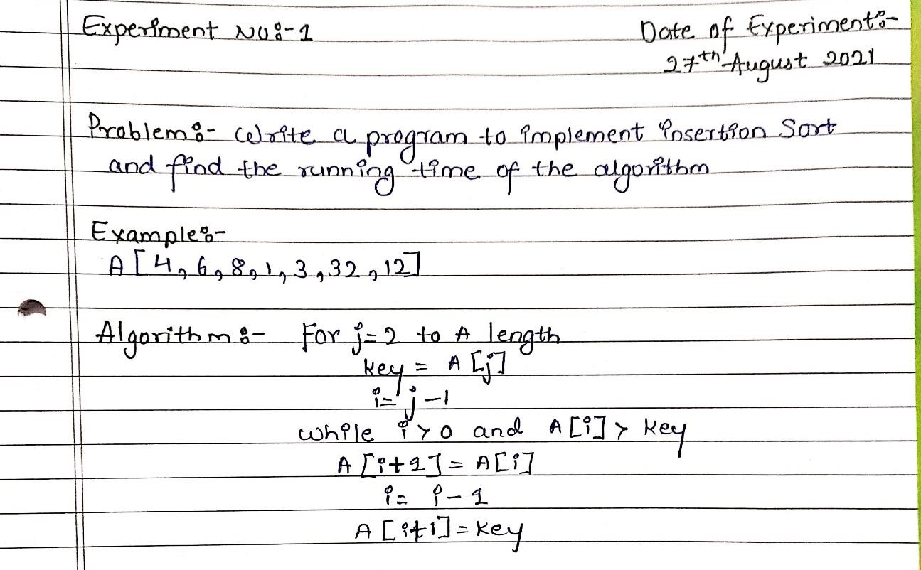

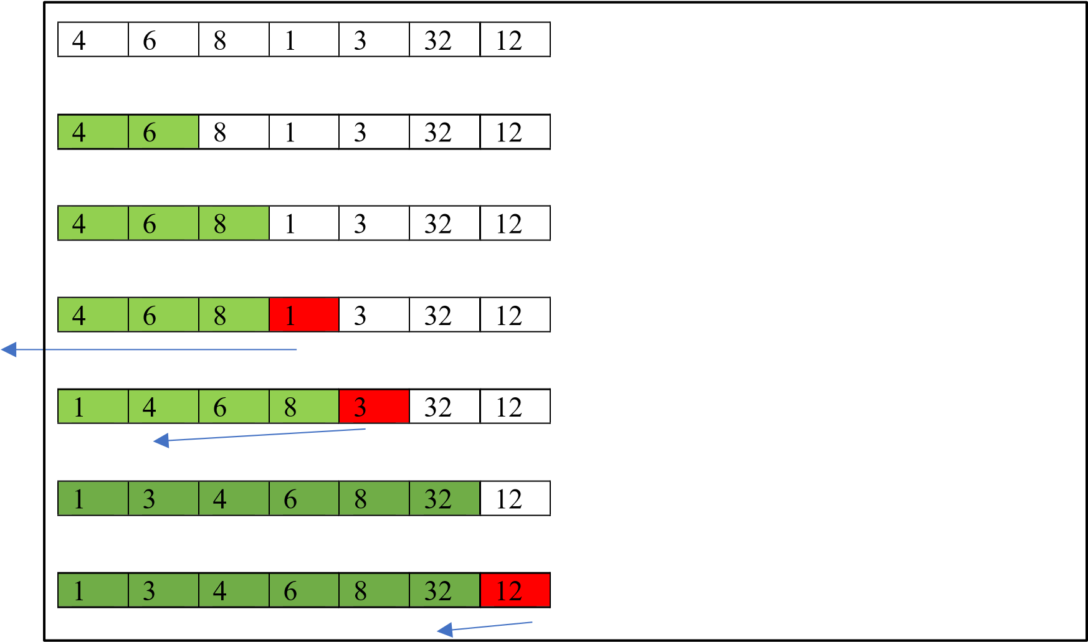

**Program:**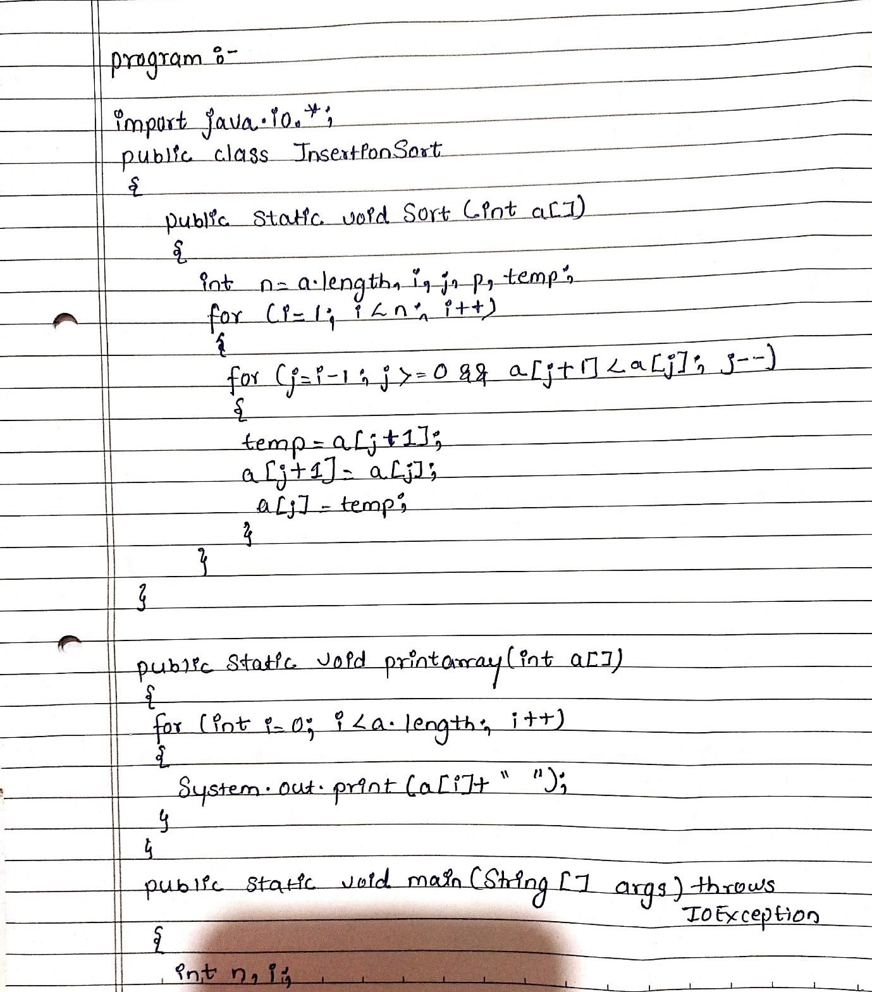

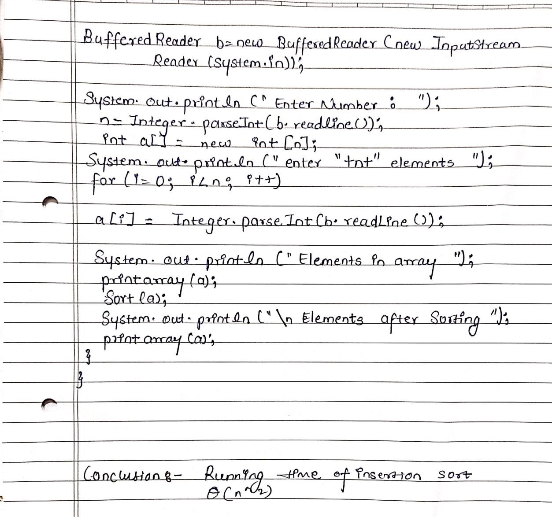

# Practical Implementation of Insertion Sort :-

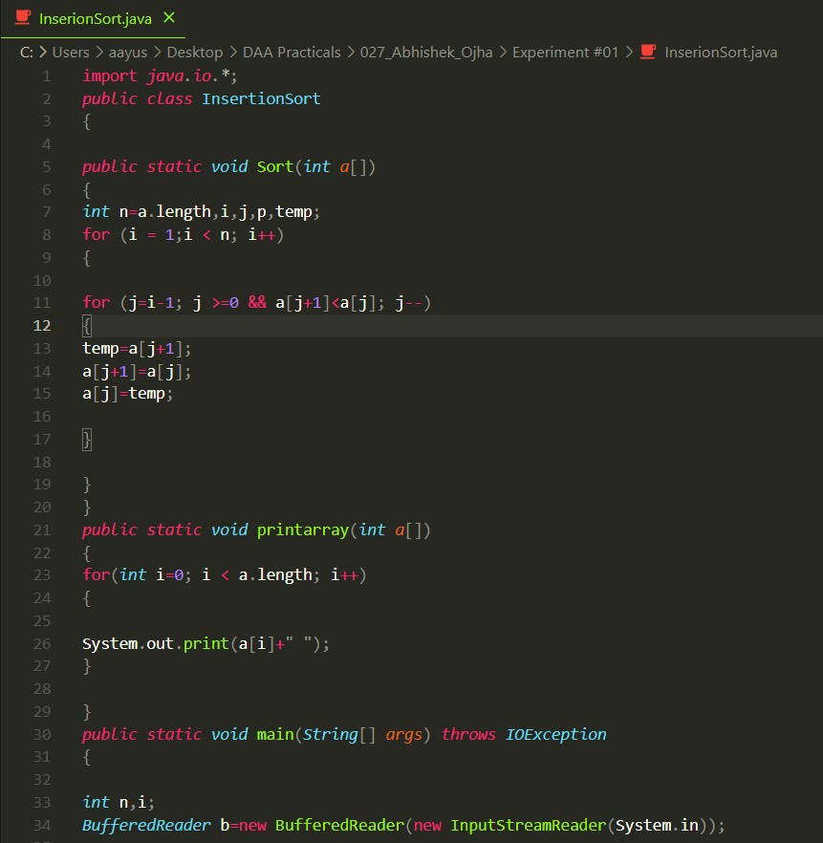

**Output:**

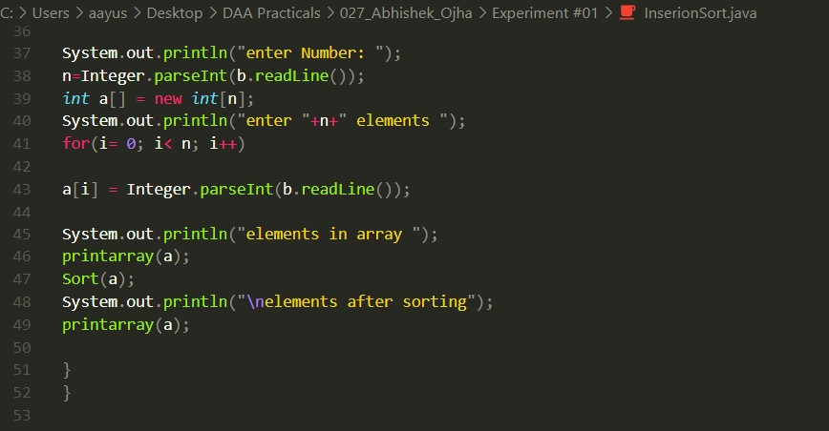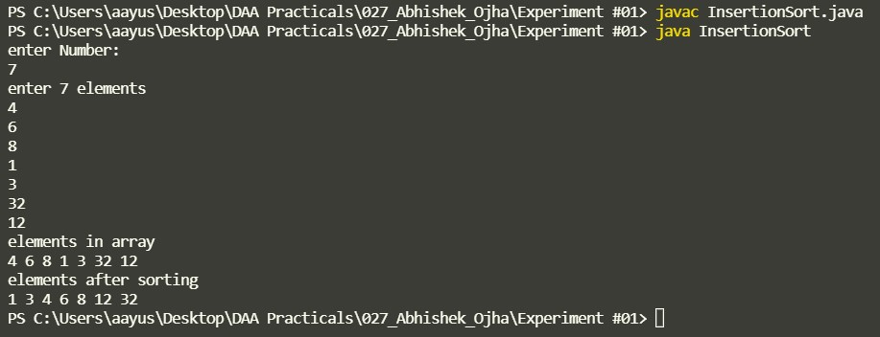

**Conclusion:** Running time of Insertion Sort 𝜃(𝑛 ^ 2)